***Admins***

* ***Admin 1***

-shall be able to see all hunts

-shall be able to see all hunts’ status

-shall be able to sort hunts by date created ascending or descending

-shall be able to sort hunts by active/inactive-shall be able to sort hunts by if they are pending approval

-shall be able to sort hunts by date started ascending or descending

* ***Admin 2***

-shall be able to create new hunts

-shall be able to set a start date for a hunt

-shall be able to set an end date for a hunt

-shall be able to set a title for a hunt

-shall be able to set a theme for a hunt (what is a theme?)

-shall be able to set the text used in player invitations

-shall be able to set a list of tasks

-shall be able to order the list of tasks

-shall be able to assign a URL to the hunt

* ***Admin 3***  
  - should be able to edit on hunts that are either active now or waiting to be started  
  - should be able to change anything with the hunt (what parts of the hunt are changeable?)  
  - should be able to edit the text in the text message that is sent out  
  - should be able to edit if a hunt is Pending or Active
* ***Admin 4***

-Be able to create accounts for a list of people

-Create accounts using email & phone number

-Find existing accounts using an access code

-Invite participant by URL, email invite, & text access code to user

-Unique access code to player and each hunt has a different code

-Access codes are either active, disabled, or pending invite

* ***Admin 5***

-Should have access to an invite-management interface

-Should be able to list, add, and remove invites

-Be able to create accounts for a list of people

-Create accounts using email & phone number

-Find existing accounts using an access code

-Invite participant by URL, email invite, & text access code to user via the server

-Unique access code to player and each hunt has a different code

-Access codes are either active, disabled, or pending invite

-Should have access to an invite-management interface

-Should be able to list, add, and remove invites

-Have a button to create invites

-The admin is required to provide the e-mail address and phone number for which to send.

-Should be able to see the invite ID, player’s display name, email address and phone number to which the invite was assigned

***Players***

***Player 1***

-Must be able to join a hunt-Must have a player unique access code that allows them to join a specific hunt

-must be able to participate as a team

***Player 2***

-More than one player can access the hunt at one time and from different computers-Must have a high refresh rate so others can see player changes’

***Player 3***

- Player must be able to report that one is at a valid location

- Program can have a button labeled "I am here" to report they are at a valid location

- Program can process camera

- Program can process QR code from camera

- Program can have button labeled "Scan QR code" to open camera and process QR code

- Program must have option to manually enter QR code if no camera

- Program must validate location for whether it is a valid entry (valid entry is within 50 feet of a valid location)

- Program must reject invalid entries

- Program must reject incomplete entries or errored entries

- Program must report to player the status of their entry

- Program must store player entries

***Players 4***

-MUST be able to see player ranking between other players

-MAY show statistics, time completed per tasks

-MUST be able to login

-MUST be able to see list of tasks associated with hunting.

-MUST have an organized to show unfinished tasks.

***Player 5***

- must be able to mark undiscovered and discovered locations

- must be able to show any spots that have interaction to them

- must be able to mark what tasks are left and what has been done

- must be able to search around the map and move it around to see the whole map

***Player 6***

-shall be able to customize their username

-shall be able to customize their profile picture

System Level Data Model

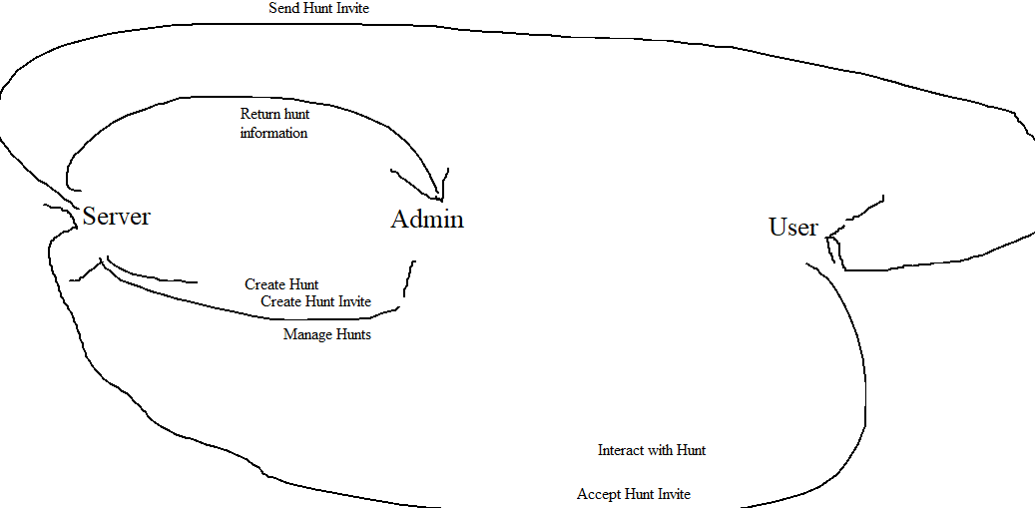

Architectural Design

Actors & Major Objects

Actors:

Users

Admins

Major Objects:

Hunts

Invites

Critical Attributes and Behaviors / Class Diagram

|  |
| --- |
| Actor: User |
| Private: Username |
| Private: Phone Number |
| Private: E-mail addr |
| Private: Hunt state data |
| Action: Join Hunt |
| Action: Interact with Task |

|  |
| --- |
| Actor: Admin |
| Private: Username |
| Action: Create Hunt |
| Action: Create User |
| Action: Edit Hunt |
| Action: Send Invite |
| Action: Start Hunt |
| Major Object: Hunt |
| Public: HuntID |
| Private: Landmarks/QR Codes |
| Private: Users bound to this Hunt |
| Private: Task List |
|  |

|  |
| --- |
| Major Object: Invite |
| Private: InviteID |
| Private: HuntID |
| Private: Username |

|  |
| --- |
| Object of Hunt: Task |
| Private: Landmark ID |
|  |

|  |
| --- |
| Object of Hunt: Landmark |
| Private: GPS Coordinates |
| Public: Landmark ID |
| Private: Map Location |
|  |

State Diagrams

Activity Diagram

Sequence Diagram

User

Admin

Data Storage

User email

User phone number

User access codes

Hunt specific access codes

Brandon Beaudry  
John Milhorn

Liam Whitelaw